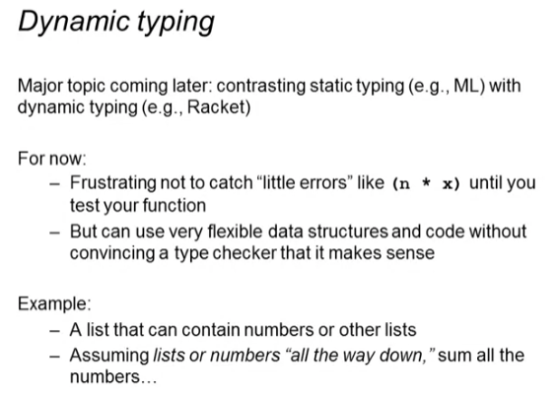

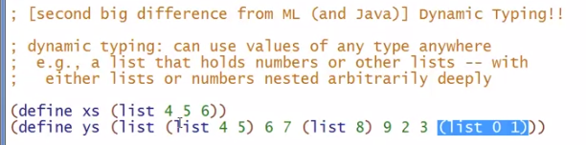

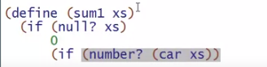

* We need this type check “number?” in the condition because our list CAN be composed of different types and we need to make sure what type we are at now (head)
  + In ML or in statically typed languages, we do not really need this because the program will not even type-check/run if we have lists with multiple types as elements

Final definition

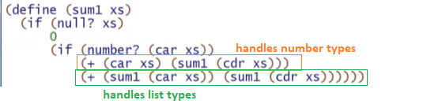

Try using it:

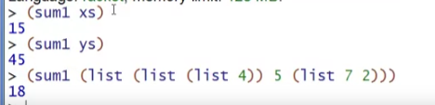

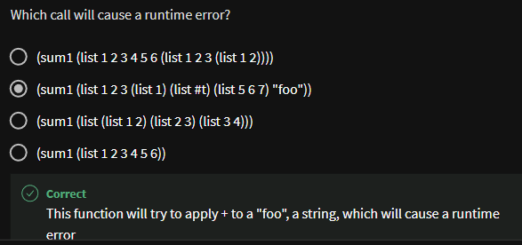

* Because we didn’t handle any string arguments!
  + We can have a fallback value in our if conditions (string? (car xs)) and (boolean? (car xs)) and skip if you really want to be able to use sum1 when the list has other arguments other than number and list of numbers

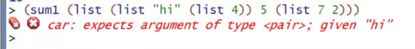

1 way of supporting this as I mentioned as fallback:

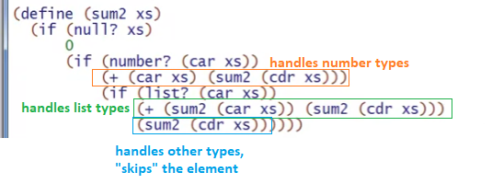



But:



* Should have LIST as 1st argument